Introduction to Politics
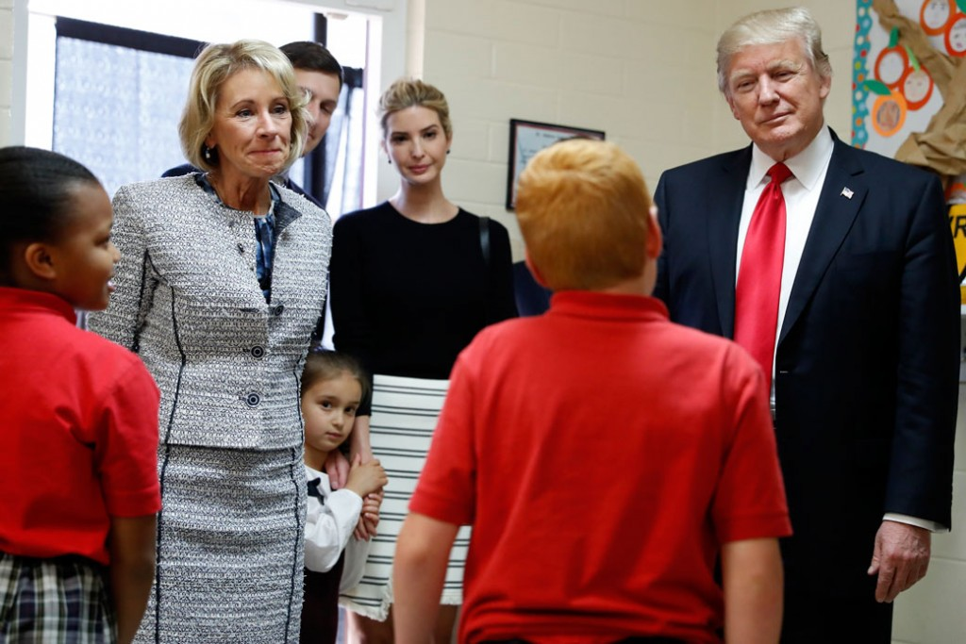
POSC 1100
Fordham University
Fall 2019
Professor Nicholas Tampio
tampio@fordham.edu
Class: Faber Hall 668, TF 10:00-11:15am
Office hours: Faber 665, T 2-4 pm and by appt

The United States is currently debating a host of important topics about education, including how to allocate power between the federal, state, and local governments; education standards in English language arts, mathematics, science, history, and sexual health; whether the primary purpose of schools is primarily to workers or citizens; whether American schools should be run like businesses; and whether America should emulate other countries’ education systems, and if so, which ones. This course aims to introduce students to the academic discipline of political science by showing what it can contribute to understanding and entering these debates.

The course begins by explaining how political scientists study the institutions, interests, and ideas involved in any policy debate. Next, we survey how the subfields of political science—American politics, political theory, comparative politics, and international relations—provide insights on current political debates. In American politics, we study the transition from local to state and federal control of education, focusing particularly on the Elementary and Secondary Education Act of 1965 and its reauthorizations. In political theory, we consider how John Dewey laid the foundation for progressive politics that has been challenged by economists such as Milton Friedman who want to apply market principles to education. In comparative politics, we examine how scholars have studied other countries—particularly in Finland and Singapore—for insights about how the US should reform its education system. And in international relations, we investigate how scholars have used economic and national security arguments to justify transforming American schools and how Yong Zhao argues that America should not emulate Asian countries with high test scores.

In the final part of the course, students research and present a policy brief on the Advanced Placement program, Success Academy charter schools, facial recognition technology, social impact bonds, active shooting drills, and Teach for America.

Student learning objectives

By the end of the semester, students should be able to successfully:
- Know the methodologies and research focus of the five main subfields of political science: American politics, comparative politics, international relations, political theory, and public policy.
- Demonstrate knowledge of the history of American education policy, including the shifting allocation of power between local education authorities, states, and the federal government.
- Understand the normative debate about whether schools should focus on training workers or citizens.
- Place American education debates in a global context.
- Research, write about, present on, and contribute to education policy debates.

Books

- Linda Darling-Hammond, The Flat World and Education (Teacher’s College Press, 2010), ISBN-10: 0807749621
- John Dewey, The School and Society & The Child and the Curriculum, ISBN: 9781611044126
- Jesse H. Rhodes, An Education in Politics (Cornell University Press, 2012) ISBN-10 0-8014-7954-1
- Sigal R. Ben-Porath and Michael C. Johanek, Making Up our Mind: What School Choice is Really About (University of Chicago Press 2019), ISBN 9780226619637
- Nicholas Tampio, Common Core: National Education Standards and the Threat to Democracy (Johns Hopkins University Press 2018), ISBN: 9781421424637

Course Requirements

(1) September 27: Before class, send me an electronic copy of a 3000-word encyclopedia entry on of the Elementary and Secondary Education Act. Write the entry with 10+ academic sources, subheadings, and formatted in the style of an academic article (see here). As an EP course, students will have a chance to revise the paper for up to a one-letter grade improvement due one week after I return the paper with comments.
(2) One week before the midterm, I will distribute 6 essay questions, and on the day of the exam we will roll a die to determine 2 questions. Good answers should incorporate material from the lectures, readings, presentations, and your own thoughts. You may study in groups, but the exam is close-booked. The exam is 1 hour.

(3, 4) Near the end of the semester, students will participate a group presentation on a controversial topic in education policy. Each student is expected to write his or her own 3000-word research paper w/ 10+ academic sources, subheadings, and formatted in the style of an academic article. For presentations, groups should make a Powerpoint that provides an overview of the history and debates on the topic. Groups should send email me a few sources to distribute to students to read before class. Find activities and pose questions to spark a lively conversation.

(5) The final has the same format as the midterm.

(6) Class participation. Students are expected to come to class on time prepared to discuss the readings.

Grade Distribution

Encyclopedia entry on ESEA 20
Midterm 20
Research paper 20
Research presentation 10
Final exam 20
Class participation 10

To understand university policies on academic rights and responsibilities, sexual harassment, prononuns, services for students with disabilities, and other important topics, please see the undergraduate faculty handbook. Please make a point to stop by during office hours at least once this semester.

Class schedule

I. Introduction

1. August 30 – How Political Scientists Study Education Policy
- Lorraine M. McDonnell, “A Political Science Perspective on Education Policy Analysis,” in Handbook of Education Policy Research (2009), pp. 57-70
- Group activity: diagram the ideas, interests, and institutions described in Education Week articles

II. American Politics

2. September 3: The Structure of American Education Policy before 1965
- Jesse H. Rhodes, An Education in Politics, pp. 26-39
- Johann N. Neem, “Path Dependence and the Emergence of Common Schools: Ohio to 1853,” The Journal of Policy History, 28, no. 1, 2016.
- Group activity: How are states using data dashboards to rate public schools? See State Dashboards, Learning Policy Institute presentation to New York Regents July 2017
- Nicholas Tampio, Common Core, Conclusion: Democracy, Education Standards, and Local Control

3. September 6: Elementary and Secondary Education Act of 1965
- Elementary and Secondary Act of 1965
- David A. Gamson, Kathryn A. McDermott, and Douglas S. Reed, “The Elementary and Secondary Education Act at Fifty: Aspirations, Effects, and Limitations,” Russell Sage Foundation, 2015.
- Group activity: Explain Title I + Title II, III, IV, V, VI

4. September 10: Systemic Education Reform in the 1980s and 1990s
- Jesse H. Rhodes, An Education in Politics, pp. 40-125
- A Nation At Risk - US Department of Education + What 'A Nation At Risk' Got Wrong, And Right, About U.S. Schools
- Marshall S. Smith, Jennifer O’Day, “Systemic School Reform” (1990)
- Group activity: How did the Improving America’s School Act of 1994 enact systemic school reform?

5. September 13: No Child Left Behind
- No Child Left Behind
- Jesse H. Rhodes, An Education in Politics, pp. 126-158
- Group activity: What do states have to do regarding standards, testing, and accountability to get Title I funds under NCLB?

6. September 17: Race to the Top
- Jesse H. Rhodes, An Education in Politics, pp. 1-25, 159-194
- Race to the Top Executive Summary
- What Did Race to the Top Accomplish? Education Next, Fall 2015
- Class activity: Watch President Obama explain Race to the Top.
- Group activity: Explain how one of the four pillars of RTTT (standards and testing; data collection; charters; value-added teacher evaluations) fits into systemic school reform.

7. September 20: Every Student Succeeds Act (ESSA)
- The Every Student Succeeds Act: An ESSA Overview
- Group activity: Study the Revised State Template for the Consolidated State Plan. Explain what states must do regarding Improving Basic Programs Operated by Local Educational Agencies +
  - Education of Migratory Children;
  - Prevention and Intervention Programs for Children and Youth Who Are Neglected, Delinquent, or At-Risk;
  - Supporting Effective Instruction;English Language Acquisition, Language Enhancement, and Academic Achievement;
  - Student Support and Academic Enrichment Grants; 21st Century Community Learning Centers;
  - Rural and Low-Income School Program;
  - Education for Homeless Children and Youth Program (McKinney-Vento Act).

8. September 24: New York’s ESSA plan
- NEW YORK STATE’S FINAL EVERY STUDENT SUCCEEDS ACT (ESSA) PLAN SUMMARY JANUARY 2018

III. Political Theory

9. September 27: John Dewey on the Child and the Curriculum
- John Dewey, The Child and The Curriculum
- Nicholas Tampio, “In Praise of Dewey,” Aeon, July 28, 2016.
- Group activity: develop a curriculum sequence for English Language Arts, math, history, science, art, sexual health.
- Encyclopedia entry on ESEA due

10. October 1: John Dewey on School and Society
- John Dewey, The School and Society
- Group activity: Imagine that you are talking to a school board. What kind of field trips would you recommend that students take? Give a Deweyan rationale.

11. October 4: Friedman on Free Market Principles in Education
- Milton Friedman, “The Role of Government in Education”
- Group activity: Do you think Friedman would support the Common Core? Find evidence from conservative think tanks such as the American Enterprise Institution, the Cato Institute, the Heartland Institute, or the Thomas B. Fordham Institute.

12. October 8: Gary Becker on Human Capital
- Gary Becker, “Human Capital Revisited”

13. October 11: The history of charter schools
- Making Up our Mind, Introduction, Part I

14. October 15: The normative debate about charter schools
- Making Up our Mind, Part II
- Deborah Meier, “Choice Can Save Public Education,” The Nation, March 4, 1991.
- Frederick M. Hess, “Does School Choice ‘Work’?” National Affairs, 2010.

15. October 18: Midterm

IV. Comparative Politics

16. October 22: The Flat World Thesis
- Thomas Friedman, “It’s a Flat World, After All,” The New York Times Magazine, April 3, 2005.
- Linda Darling-Hammond, The Flat World and Education, Ch. 1

17. October 25: America’s Educational Inequality
- Linda Darling-Hammond, The Flat World and Education, Chs. 2-5
* Bibliography of research paper due

18. October 29: How Other Countries Do It, Part I
- Linda Darling-Hammond, The Flat World and Education, Ch. 6, 7

19. November 1: How Other Countries Do It, Part II
- Pasi Sahlberg, “Education Policies for Raising Student Learning: The Finish Approach,” Journal of Education Policy, vol. 22 (2), March 2007.
- Diane Ravitch, “How, and How Not, to Improve the Schools,” New York Review of Books, March 22, 2012.
- Class activity: Watch Pasi Sahlberg’s TED talk
- Group activity: Make a list on the differences between GERM and the Finnish model.

V. International Relations

20. November 5: Economic Prosperity and National Security
- Eric A. Hanushek, Ludger Woessman, “The Economic Benefit of Educational Reform in the European Union,” CESifo Economic Studies, 58, no. 1, March 2012.
- Class activity: Watch PISA video
- Group activity: Take online PISA tests

21. November 8 – Yong Zhao on Chinese and American Education
- Yong Zhao, World Class Learners, Chapter 5
- Diane Ravitch, “The Myth of Chinese Super Schools,” New York Review of Books, November 20, 2014.

Part V: Policy Debates

23. November 12: Has the Common Core worked?
- Nicholas Tampio, Common Core, Introduction, Chapters 1-4
- Reviews: Wall Street Journal, The American Conservative
24. November 15: Should colleges award credit for AP courses?

25. November 19: Should New York increase the number of Success Academy charter schools?

26. November 22: Should schools (such as in Buffalo) use facial recognition security systems?

26. November 26: Can Pay for Success (social impact bonds) succeed in early childhood development?

27. December 3: Are active shooting drills necessary?

28. December 6: Is Teach for America a good thing?

Final Exam – Friday, December 13, 9:30 am

